**TARGEDAU Y WOBR ARIAN**



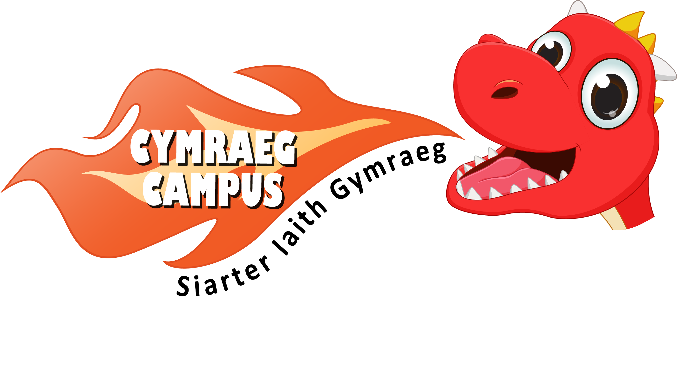

**SILVER AWARD TARGETS**

**GWOBR ARIAN: Targed 1**

**Establishing a visual Welsh ethos**

A Welsh display in classroom Welsh displays outside

linked to current topic. classrooms.

The reception area and hall Welsh is clearly visible at

reflects a contemporary vision an appropriate level on

of Wales. many displays.

Welsh is prominently displayed Criw Cymraeg contribute

around the classroom e.g. to the school’s newsletter

* welcome poster on the door reporting on Welsh activities

* most of areas named in Welsh and the school’s progress

* most of materials are labelled with the language charter.

in Welsh

Welsh is prominent on the

Most areas inside and outside school’s website e.g.

of the school have Welsh / * Welsh signage on school

bilingual signage. website

* Links to online activities

for parents and children

* Examples of Welsh activities

Pupils work on a project to undertaken in classrooms

prominently display the word * Photos and videos of Welsh

‘Croeso’ outside of the school celebrations and activities.

e.g. large mural, mosaic etc…

School’s progress in Language

Charter’s Silver Award is

clearly displayed.



**GWOBR ARIAN: Targed 2**

**The advantages of learning Welsh**

Pupils watch videos from the Each class has a take home

HWB resource ‘Ein Hiaith’ to Welsh initiative mascot whose

become aware of their Welsh news is recorded at the

identity. appropriate level in his/her

diary.

Pupils to create an iBook that

includes text, photos and short Parents are invited to view

videos that promote the advantages teachers introducing Welsh

of learning Welsh. activities.

Pupils create a poster the The school is taking advantage

advantages of learning of sabbatical courses for

Welsh. teachers and support staff to

further their Welsh language

skills.

Pupils can confidently converse

about the benefits of learning

Welsh. The school establishes a link

with a Welsh medium school /

Welsh stream within a school

Pupils can confidently sing the so that pupils can for example

Welsh National Anthem and some take part in art lessons via

traditional Welsh songs. video link.

Cwricwlwm Cymraeg is

clearly planned for.



**GWOBR ARIAN: Targed 3**

**The use of incidental Welsh in the classroom**

Teaching staff use take advantage Support staff take advantage

of every opportunity to use of every opportunity to use

incidental Welsh. incidental Welsh.

Pupils use more challenging Support staff take advantage

Welsh phrases when expressing of every opportunity to use

need incidental Welsh when working

e.g. with groups of children.

Ga i fenthyg…

Ga i ddefnyddio…

Teachers greet and ask each

other basic questions in

Each class used the ‘Helpur Welsh.

Heddiw’ initiative during

registration.

Pupils understand and

respond to more complex

Teachers and pupils follow a Welsh questions and

script for example to discuss commands.

the weather, day of the week

etc…

Teachers write a general marking

comment in Welsh in pupils’

workbooks in the majority

of subjects.

The date is written in Welsh on

the whiteboard and in pupils’

workbooks in the majority

of subjects.



**GWOBR ARIAN: Targed 4**

**The use of incidental Welsh outside of the classroom**

Dinner staff use basic Welsh The school holds a termly

when serving children e.g. themed Welsh afternoon e.g.

Beth wyt ti eisau? ‘Welsh rugby for developing

Wyt ti eisiau? the pupils’ language skills

across a range of practical

activities e.g. ICT, craft etc…

Criw Cymraeg to establish a hot

spot e.g. Pod Siarad / Cornal

Cloncan, during break times Criw Cymraeg and staff to

where pupils are rewarded model Welsh yard games.

for holding a simple conversation

in Welsh with a Criw Cymraeg

member. Pupils understand and respond

to more complex Welsh

questions and commands when

Criw Cymraeg to work on two outside of the classroom.

projects to promote use of

Welsh outside of the classroom

e.g. Fruit shop is run in Welsh

Prepare a ‘bocs Cymraeg’

for wet break / breakfast club

Prepare language posters for

the dinner hall.

Teaching staff and support

take advantage of every

opportunity to use incidental

Welsh outside of the classroom.

Phone calls are answered in

Welsh and answerphone message

is bilingual.

 Staff and pupils welcome visitors

in Welsh.

**GWOBR ARIAN: Targed 5**

**Welsh in assemblies**

Criw Cymraeg are responsible for Criw Cymraeg introduce the

leading the majority of the weekly phrase of the week in the

Welsh assembly. weekly Welsh assembly and

model how it can be used.

Headteacher and teaching staff

greet and use basic Welsh Criw Cymraeg hand out Welsh

commands during every assembly. rewards in the weekly Welsh

assembly.

Criw Cymraeg introduce and

lead the Welsh prayer using basic Classes take it in turns to

phrases in the weekly Welsh showcase short dramas, role

assembly. plays, storytelling during the

weekly Welsh assembly.

Criw Cymraeg introduce and lead

Welsh hymns and songs using

basic phrases in the weekly

Welsh assembly.

Criw Cymraeg greet pupils and staff

and Welsh music is played whilst

children enter and exit the Weekly

Welsh assembly.

A weekly Welsh assembly is held

and all staff attend.



**GWOBR ARIAN: Targed 6**

**Apps and websites to enhance learning and enjoyment**



Pupils make good use of the ‘Ap Geiriaduron’ is installed

discussion feature on the HWB school iPads and pupils can

platform to express opinion on confidently use it to check

different subjects in Welsh. spelling and meaning.

Most oracy activities completed Pupils use iPads / cameras to

by pupils are showcased record oracy activities and use

in pupils workbooks using QR codes. programs e.g. iMovie or

Windows Movie Maker to

edit clips to make short movies

Pupils have access to iBooks on

school iPads to enhance their

learning. Pupils prepare a pamphlet

presenting information on

Welsh apps and mainstream

Pupils have access to and make apps that can be used in Welsh.

good use of Welsh apps e.g. Alun

yr Arth, hapus, Campau Cosmig.

They also use mainstream apps

in Welsh e.g. puppetpals, sock

puppets to enhance their learning.

Pupils use word processing

programs to complete a range of

written tasks using different formats

during their Welsh lessons.

A list of suitable Welsh websites is

readily available in each class.

**GWOBR ARIAN: Targed 7**

**Enrichment activities**

The school annually takes part in The Criw Cymraeg organise

the Urdd Eisteddfod stage and / or events to celebrate Dydd Gwyl

literary competitions for Welsh Dewi, Diwrnod Shwmae etc…

learners.

The school organises Welsh trips There is an emphasis on Welsh

e.g. to Llangrannog, Caerdydd when creating and selling

Glanllyn, Sain Ffagan etc… to products for enterprise activities

develop pupils use and enjoyment e.g. bilingual Welsh Christmas

of Welsh. cards, decorated cakes.

The school annually takes part in The school runs a lunchtime or

Urdd sport activities. after school Welsh club with a

variety of activities.

The school regularly invites

Welsh speakers into school.

The school organises an annual

Welsh Eisteddfod where all singing,

recitation and homework

competitions are through the medium

of Welsh.

The majority of KS2 pupils are

members of the Urdd.



**GWOBR ARIAN: Targed 8**

**Developing reading**

Pupils have regular guided Pupils undertake a range of

reading sessions and are activities to improve reading

encouraged to discuss content. fluency and teachers encourage

Record of these sessions are pupils to make good use of

kept. reading success criteria cards to

peer and self assess.

Teachers and classroom assistants

have been given training on Year 6 pupils conduct guided

language needed to facilitate group reading sessions with younger

reading using e.g. Cynllun Colegau pupils.

Cymru Language Mat.

Most pupils have a secure Each pupils has an individual

grasp of the Welsh alphabet. Welsh reading book and has

a record of books read.

Pupils have access to iBooks on

school iPads to enhance their Pupils are able to ask and

learning. answer a range of questions

about books and express

their opinion.

The school creates a rich Welsh

reading environment e.g.

* school library has a Welsh

section

* phrases to discuss books are

displayed

* Welsh dictionaries are

available.

The school has recently undertaken

 an audit of current resources and

has invested in a good range of

current suitable reading books and

magazines.

**GWOBR ARIAN: Targed 9**

**Welsh across the curriculum**

KS2 teachers regularly make Pupils evaluate their work at

use of factual books e.g. ‘Ein an appropriate level in Welsh

Cymru Ni’, ‘A wyddoch chi?’, subjects e.g. Art, Design and

‘Patagonia’, ‘Botswana’ etc… Technology, Music etc… by

using familiar patterns e.g.

Dw i’n meddwl bod…

KS2 teachers regularly use

cross-curricular books e.g. Pod

Antur books and DVD clips as a There is evidence of Welsh

tool for learning aspects of their cross-curricular work undertaken

topic work in Welsh. in pupils topic and subject

workbooks.

Teacher use Welsh across the

curriculum key ring cards, posters Pupils have a good grasp of

and language mats to aid pupils to subject terminology in Welsh in

use Welsh across the curriculum. the majority of subjects across

the curriculum.

Bilingual opportunities are included

in most lesson plans. Aspects of one subject e.g. P.E.

or Art is taught through the

medium of Welsh in all classes.

Welsh is clearly visible at an

appropriate level on many

displays.



**GWOBR ARIAN: Targed 10**

**A positive attitude**

Pupils play a variety of games Pupils are provided with a range

through the medium of Welsh of audio / audio visual Welsh

e.g. stimuli and are able to participate

* classroom language games in a range of exciting activities

* yard games through the medium of Welsh e.g.

* warm up games during P.E. * Welsh DVDs

lessons * Welsh TV programmes

* interactive games * Jamboree

* drama workshop

* arts project

The school has a half-termly

evolving graffiti wall where pupils

respond in Welsh to a question asked Pupils are given the opportunity

by teachers or the Criw Cymraeg. to use Welsh in a range of

real life situations e.g.

* buying items

* ordering food

The Criw Cymraeg distribute

rewards in the weekly Welsh

assembly e.g. Questionnaire shows that

* siaradwr y wythnos most pupils enjoy learning

* dosbarth y wythnos Welsh.

The school uses a variety of

ways to reward children and

staff for speaking Welsh e.g.

* win a place on the Welsh

dinner table in the dinner hall

* tocyn iaith

* team points

* certificates

 The school has an active Criw

Cymraeg which leads on

developing Welsh in the school.

Welsh stickers or stamps are

used to reward good work.

Teachers use a bank of simple

marking comments in Welsh.